This is the YouTube link to our bonus presentation on Network switches.
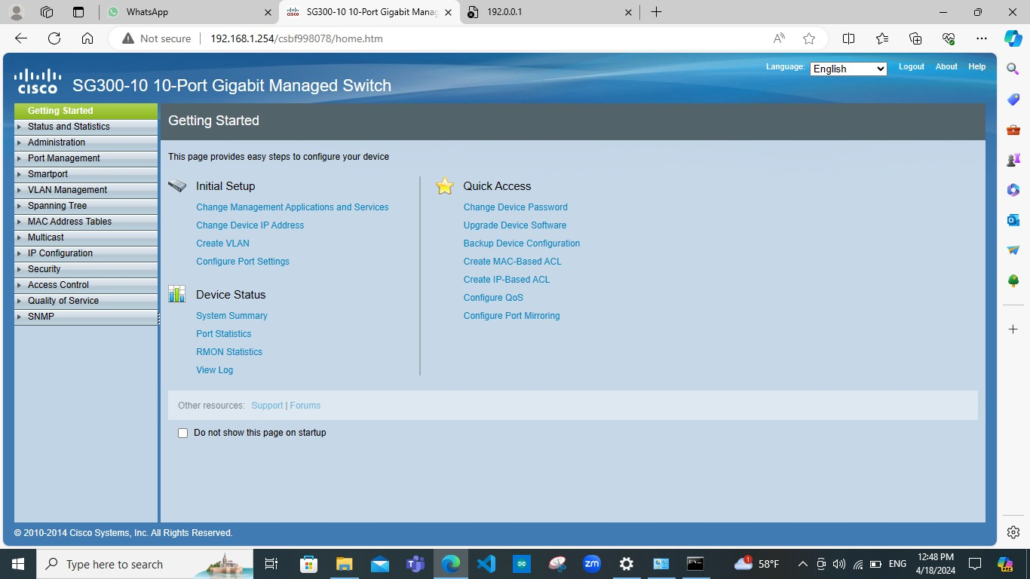
Link: https://youtu.be/sAYIAODHb6w

